**SCREENSHOTS**

1. Login Page (Logging in with Admin Account)

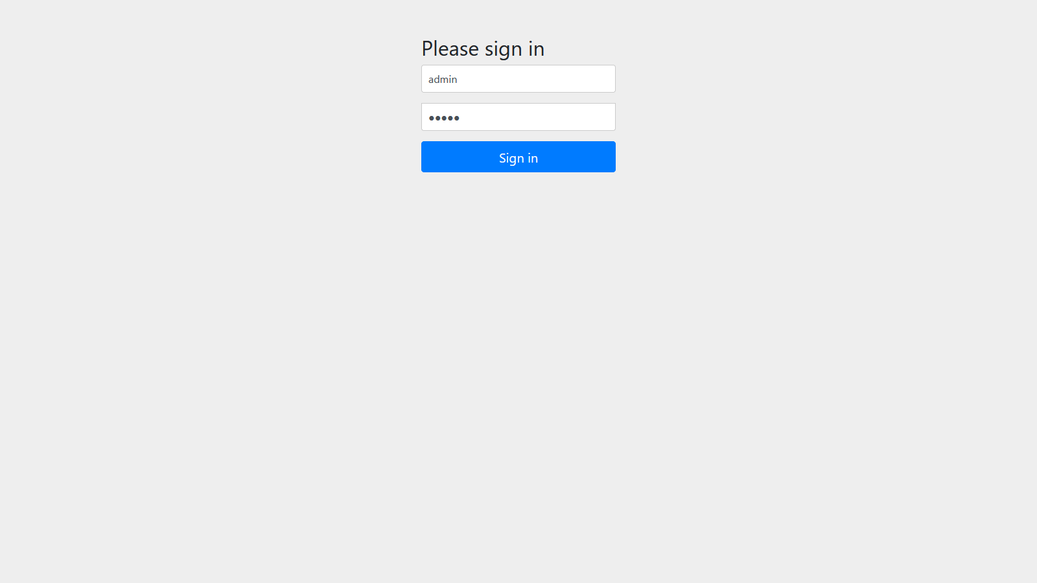

1. The list of all the Students after Admin login

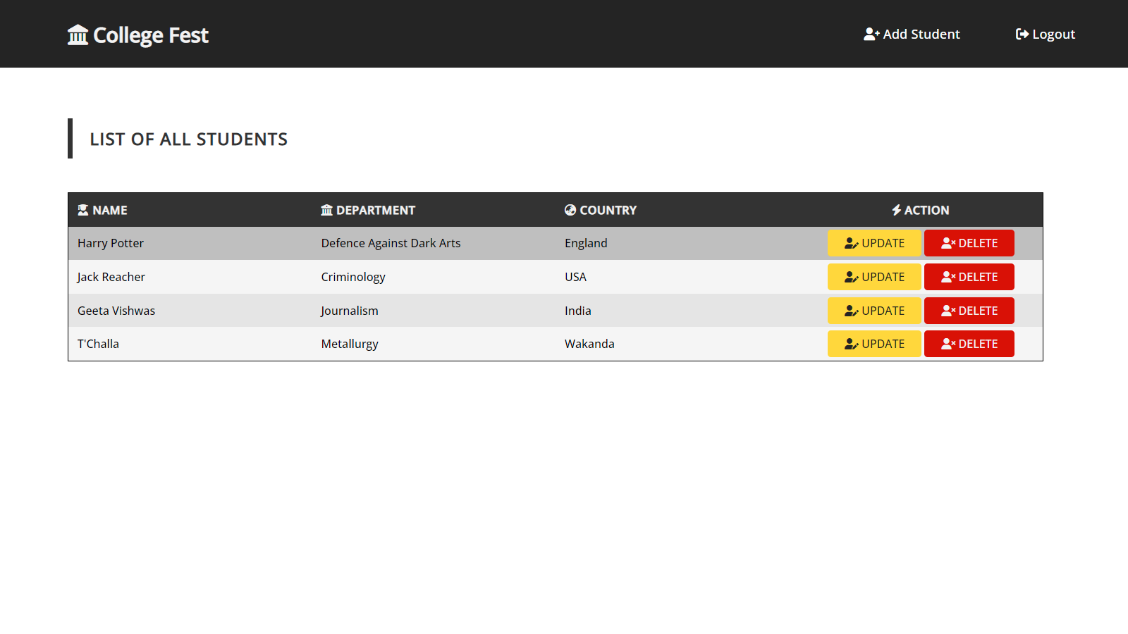

1. The blank Student Form to save the Student Details

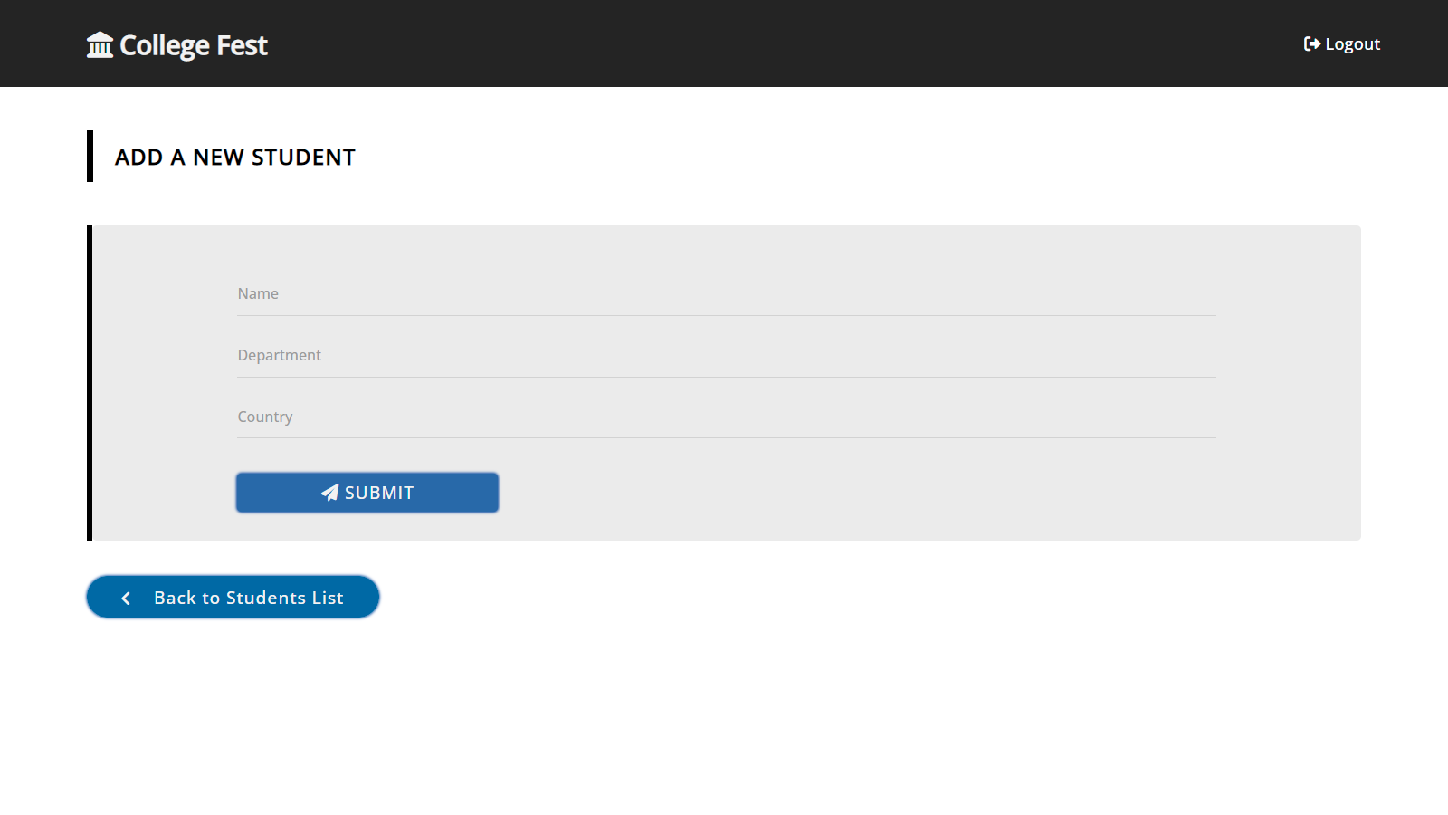

1. The validation on the Student Form

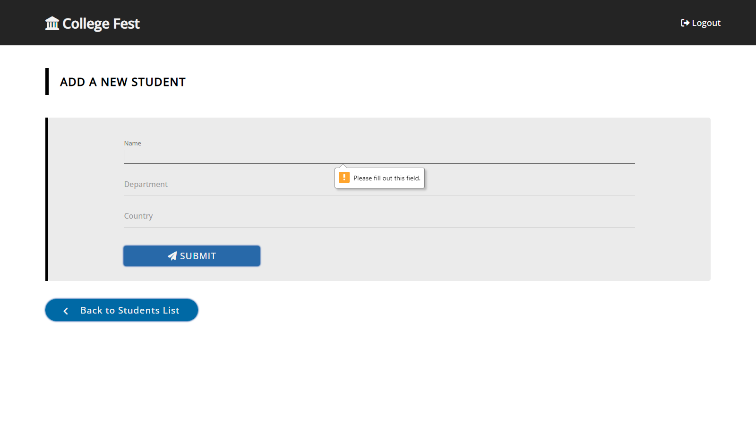

1. The Student’s Details are entered in the Student Form

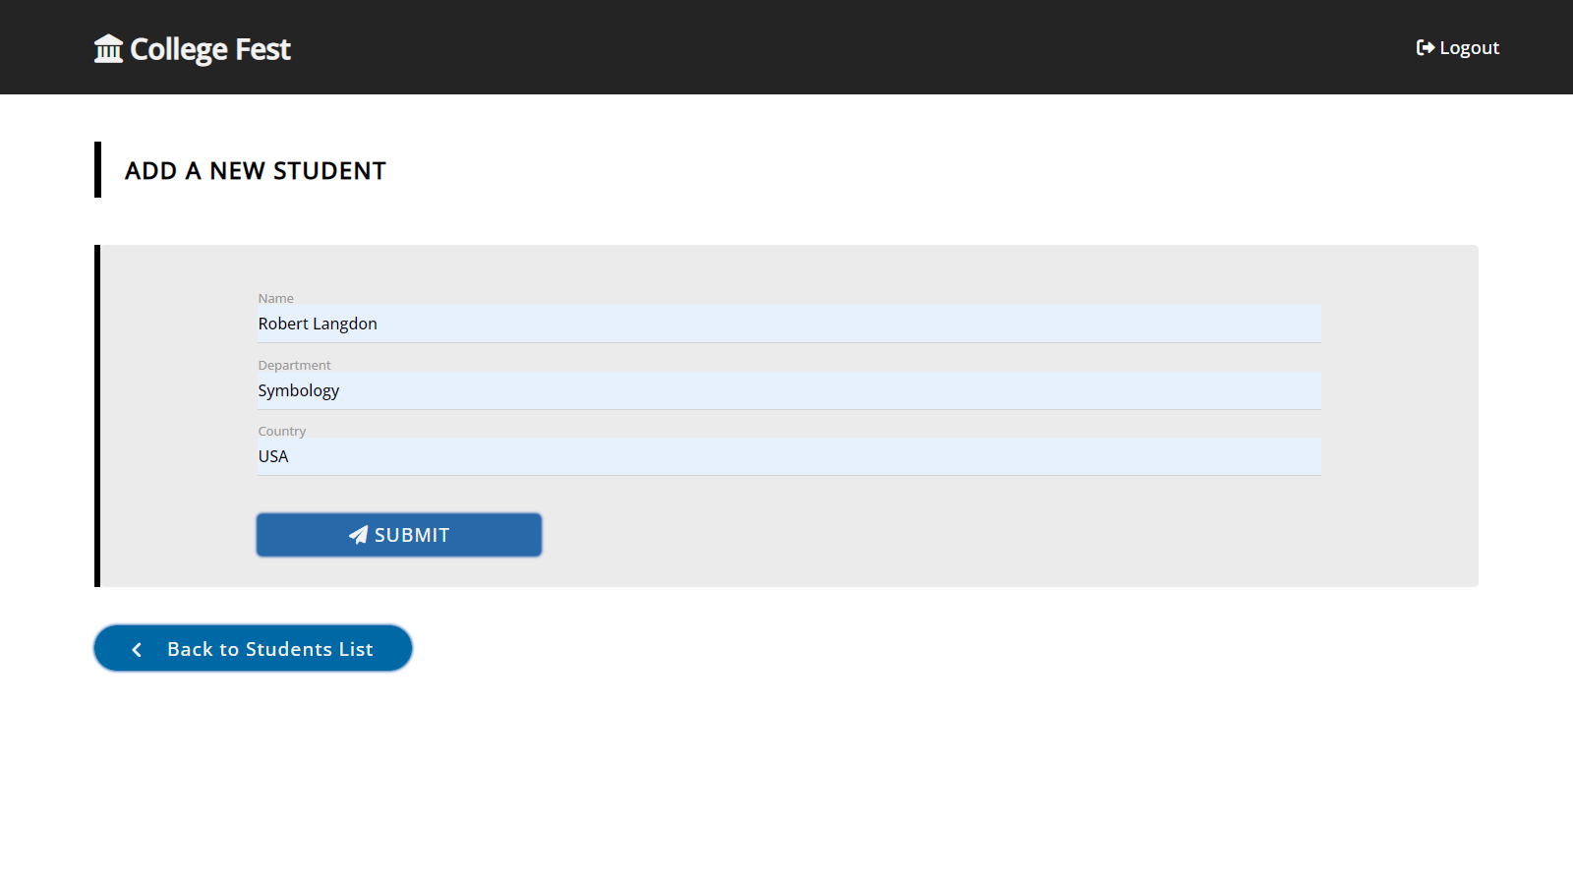

1. The updated list of the Students

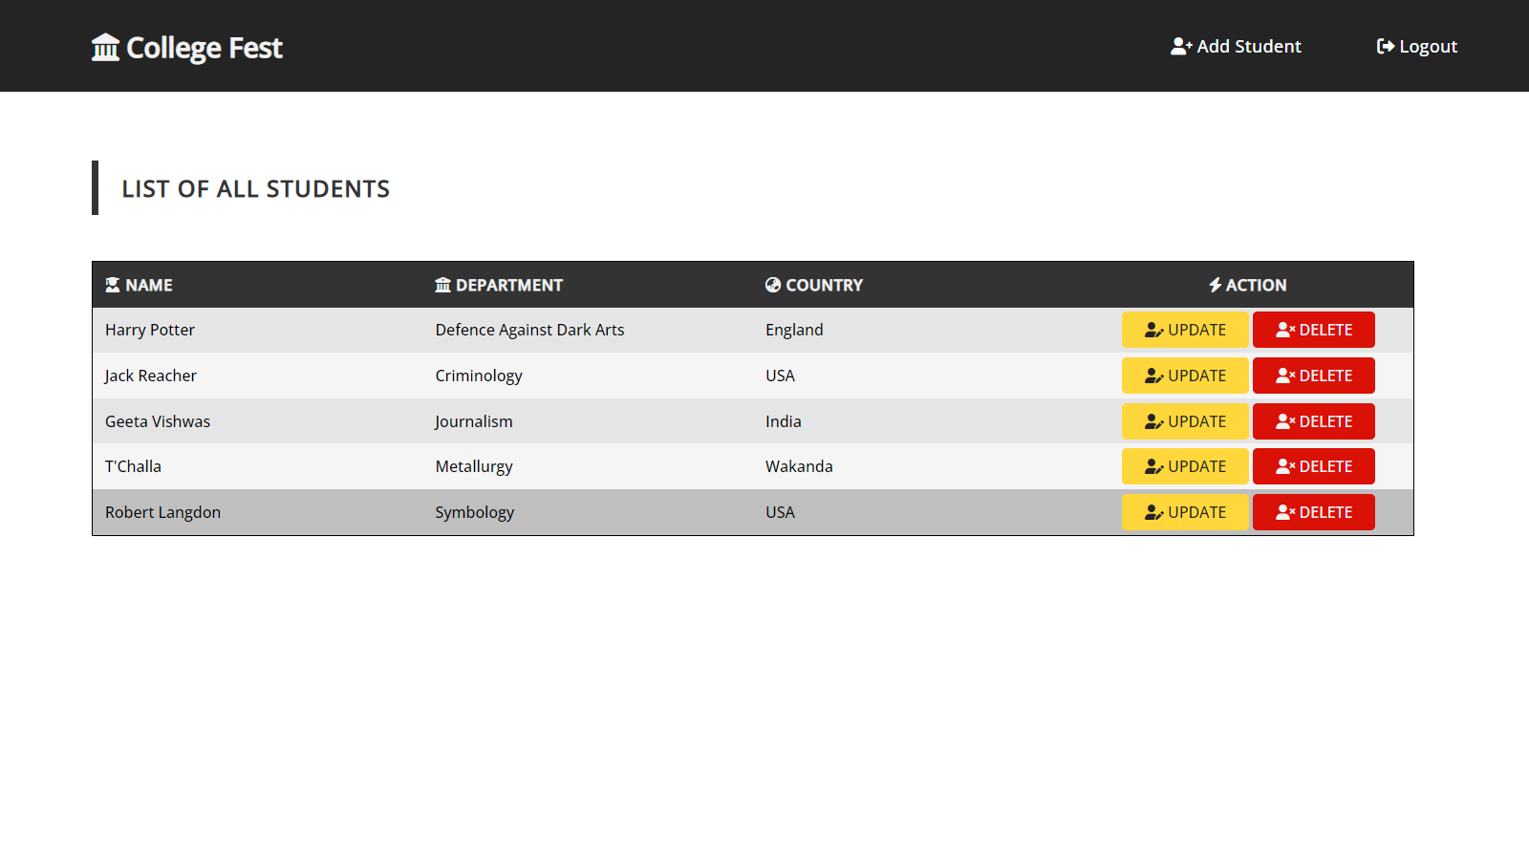

1. To update the Student Details, we are directed to the Student Form page with pre-filled values of the selected Student (Only For Admin Account)

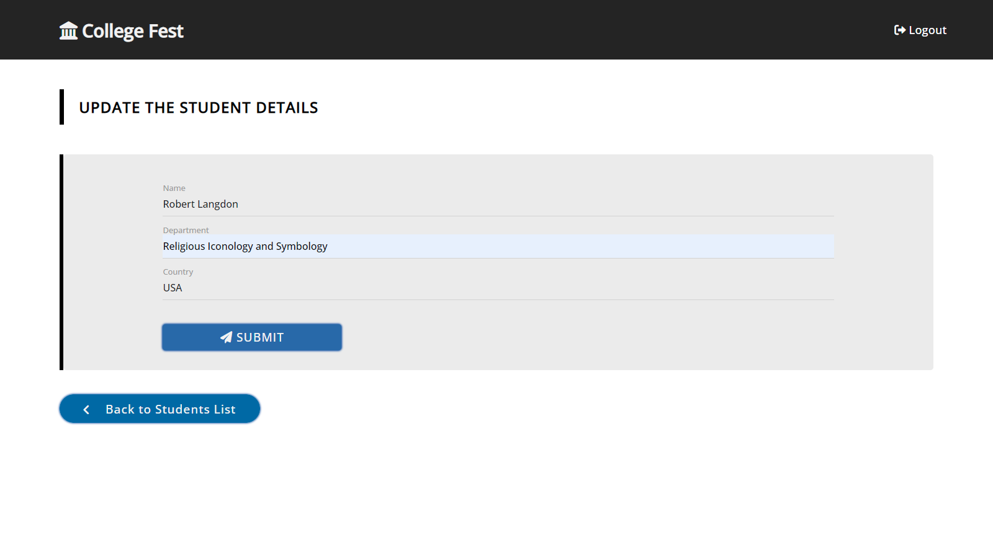

1. The updated Student’s details in the list of the Students page

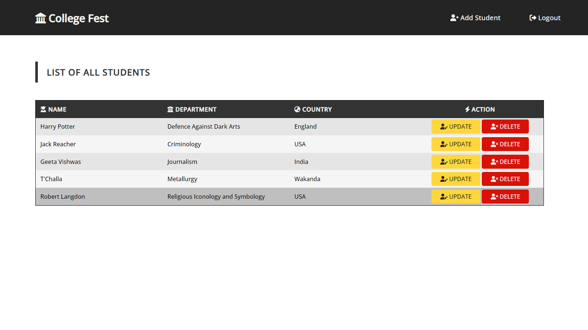

1. On clicking the delete button, a pop up is generated to confirm the deletion (Only For Admin Account)

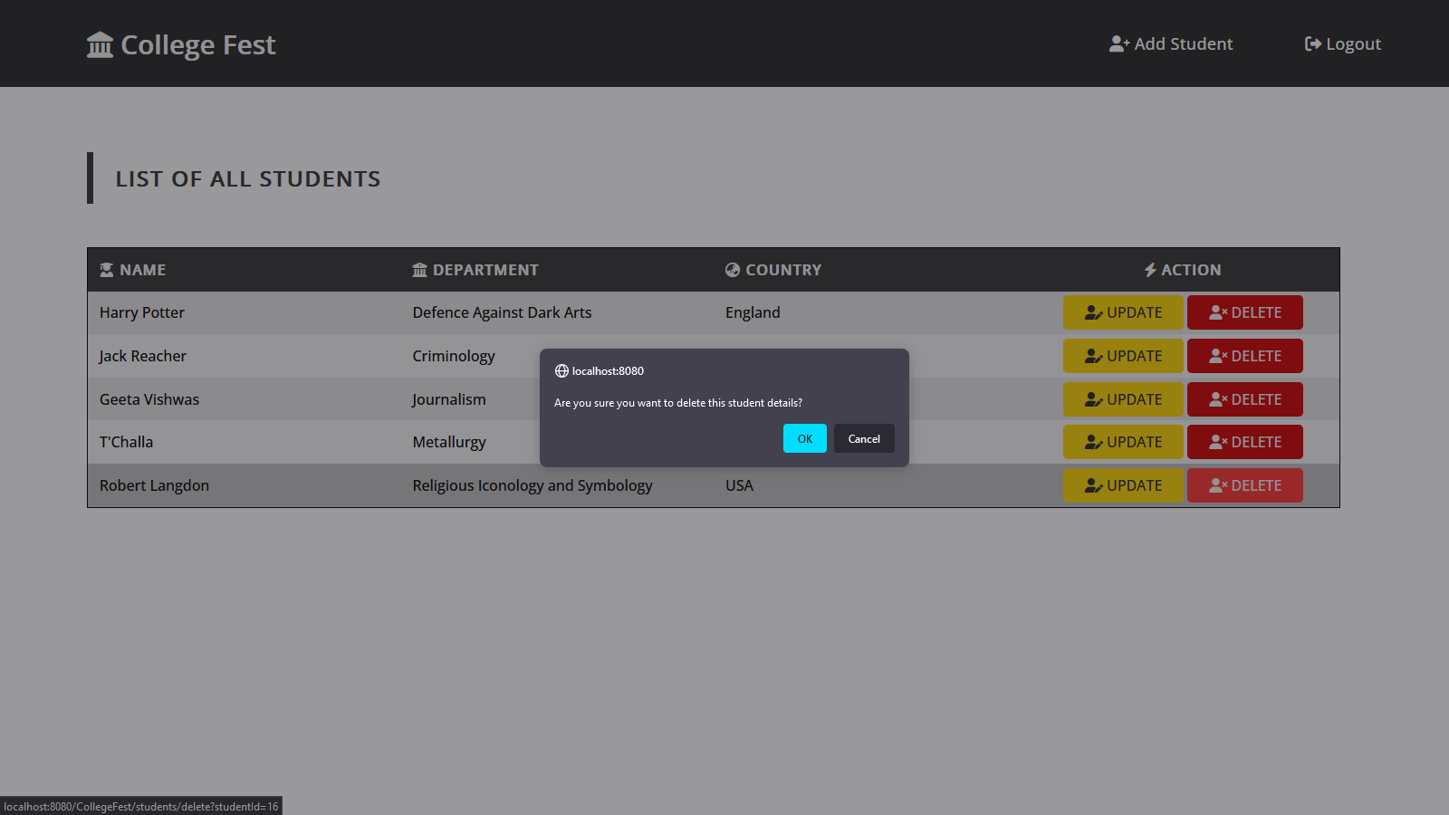

1. The updated list of the Students

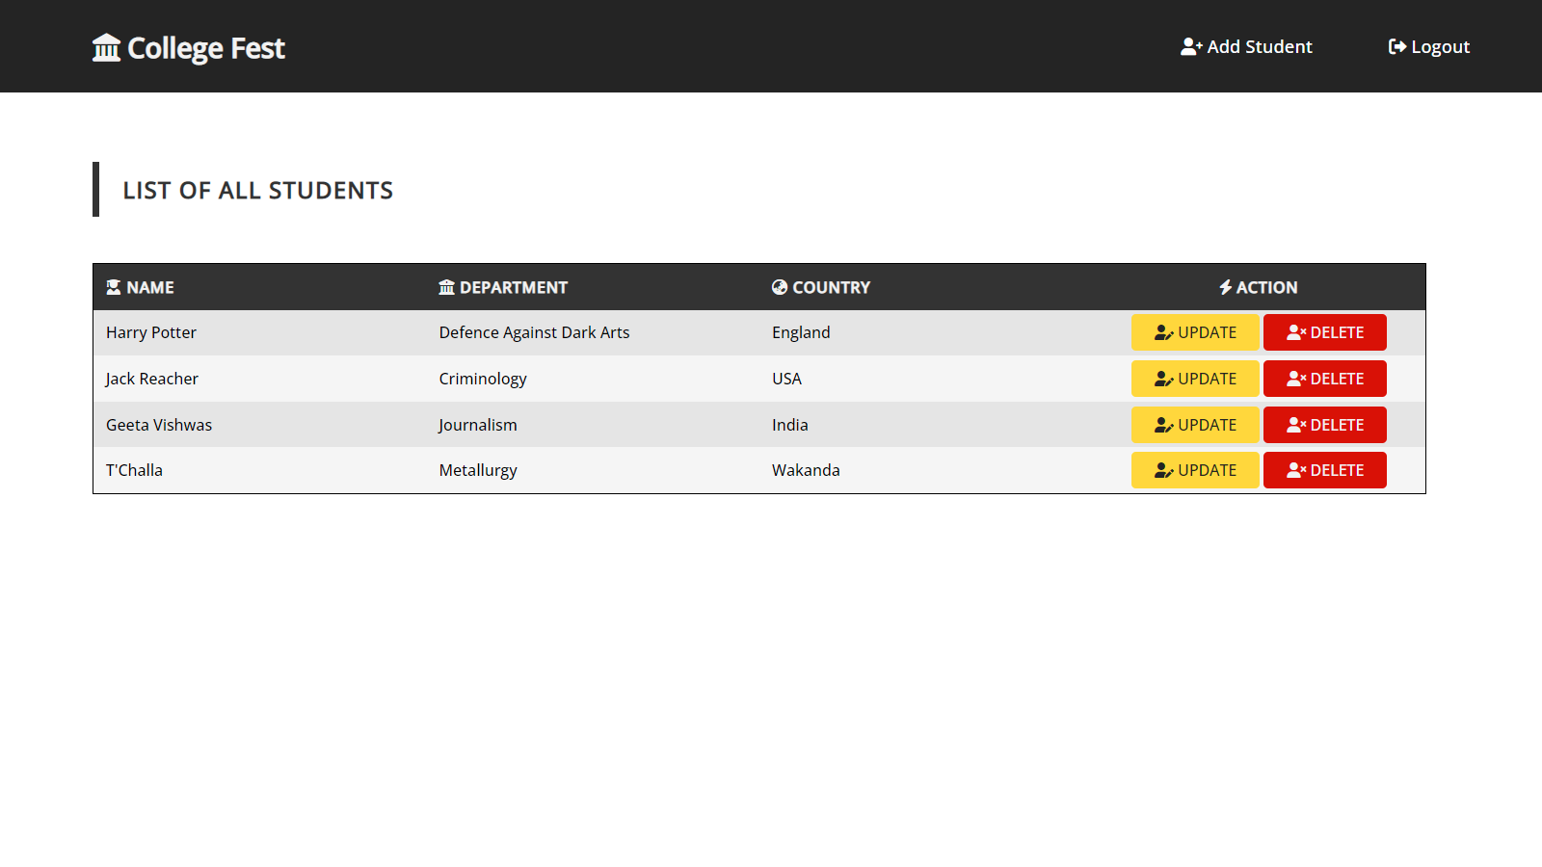

1. Logout



1. Logging in with User

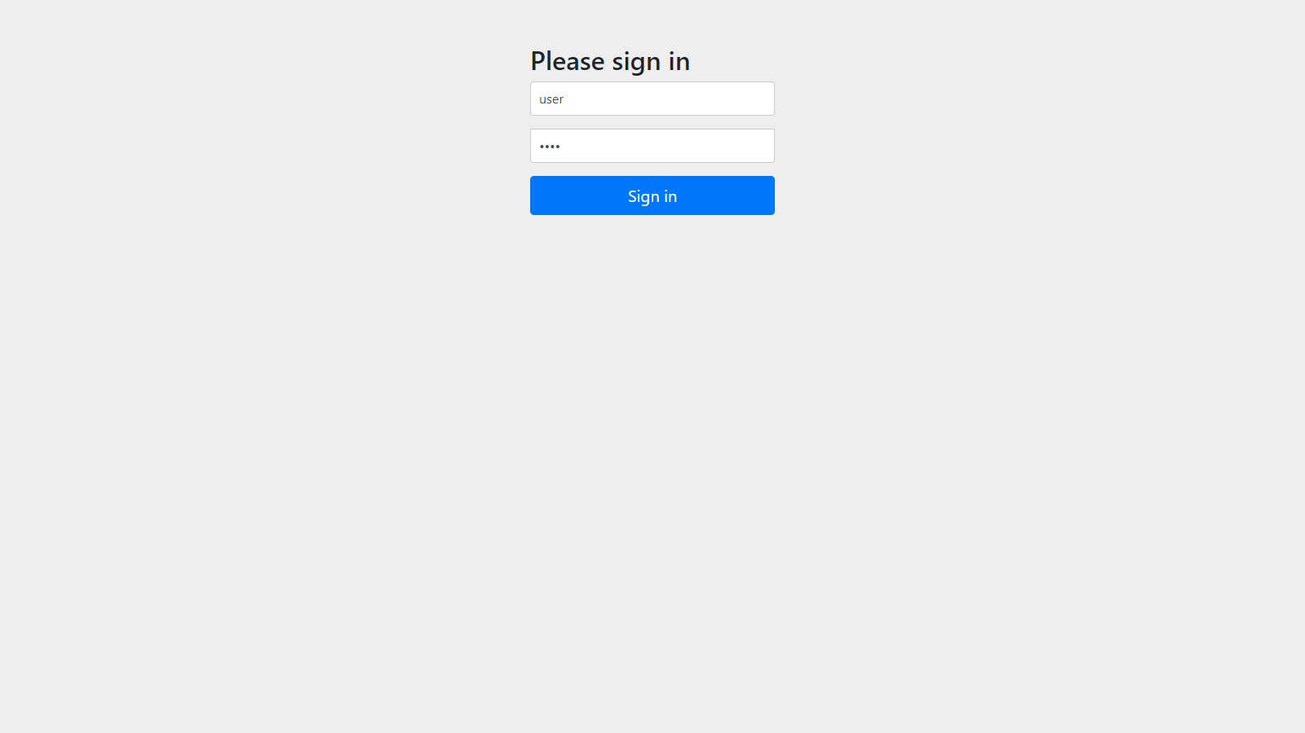

1. 403 error page while trying to update the student details

